Machine learning for STM operation and data analysis

Jiuquan Sha,a,d Lina Sang,a,d Zhi Li, a,d* Guangsai Yang,a Zengji Yue, a,d Peng Liu a, Michael S. Fuhrer b, Qikun Xue c, and Xiaolin Wang a,d *

aInstitute for Superconducting and Electronic Materials (ISEM), Australian Institute for Innovative Materials (AIIM), University of Wollongong, Wollongong, NSW 2525, Australia

bSchool of Physics and Astronomy, Monash University, Victoria 3800, Australia

cState Key Laboratory of Low-Dimensional Quantum Physics, Department of Physics, Tsinghua University, Beijing 100084, China.

dARC Centre of Excellence in Future Low-Energy Electronics Technologies (FLEET), University of Wollongong Wollongong, NSW 2525, Australia.

Corresponding Authors

Xiaolin Wang: xiaolin@uow.edu.au; Zhi Li: zhili@uow.edu.au

ABSTRACT

The capability of visualizing and manipulating individual atoms makes STM a powerful tool for studying the surface reconstruction, single molecule in-situ reaction and quantum device construction. However, because of the complex of STM operation and the presence of noise and artifacts in the STM images, either the collection or the interpretation of STM images is time-consuming and heavily dependent upon experience of the well-trained expertise. In addition, the large amounts of data generated by STM can be overwhelming and difficult to analyze using traditional methods, motivating the development of highly automated instruments and effective image analysis methods. Recently, machine learning (ML) techniques have developed rapidly and already proved to be speeding up those data collection and analysis process. Due to its ability to analyze large amount of data, recognize patterns, and make predictions based on that data, with the help of machine learning algorithms, new opportunities are emerging at the interface between STM and machine learning (ML) methods. Here, we review the recent progress of implementing machine leaching techniques in improving the efficiency of STM controlling and data analysis, including the entire workflow of data collection，management, analysis and discuss methods and resources potential to solve the problems in the process of autonomous operation, high throughput data acquirement, and data analysis of STM.

1. **Introduction**

Scanning tunnelling microscopy (STM) is a type of advanced microscope used to study the surfaces of conducting materials [1], which is widely used for studying chemical reactions [12], designing new materials and devices with desired properties [11], manipulating and controlling quantum states.[8][9] [10]. The powerful ability to uncover the linkage between the structural and the electronic information in atomic scale [2], and to manipulate individual atoms and molecules [3] [4][5], have been leading to revolutionized advancements in fields such as surface science [7], nanotechnology [6], and materials science,

STM is a kind of microscope kept an extremely sharp metal tip close to the surface of conductive materials, by applying a small bias voltage, the current (the electronic states in the surface of conductive sample) tunnels between the tip and the surface through the ‘vacuum layer’, which directly reflect the profile of the sample surface [Fig1.A)] .Owing to the highly localized nature of the tunnelling current (The tunnelling current increases exponentially as the distance between them decreases),



atomically resolved images could be obtained by raster-scanning the tip over the surface while using a feedback loop to keep the tunnelling current constant [Fig1.B)]. By modulating the voltage applied to the tip, with recording the resultant change in current, while keeping the tip at fixed distance from the surface in real time, the powerful capability of building a linkage between the structure and property through the local electronic structure of the sample can be achieved [Fig1.C)]. As for atoms manipulation, single atom can be manipulated by STM tip through applying a voltage pulse, which induces an electric field strong enough to attract or repel individual atoms on the surface. By carefully controlling the voltage and positioning of the tip, atoms can be moved, or added to the surface [Fig1.D)].

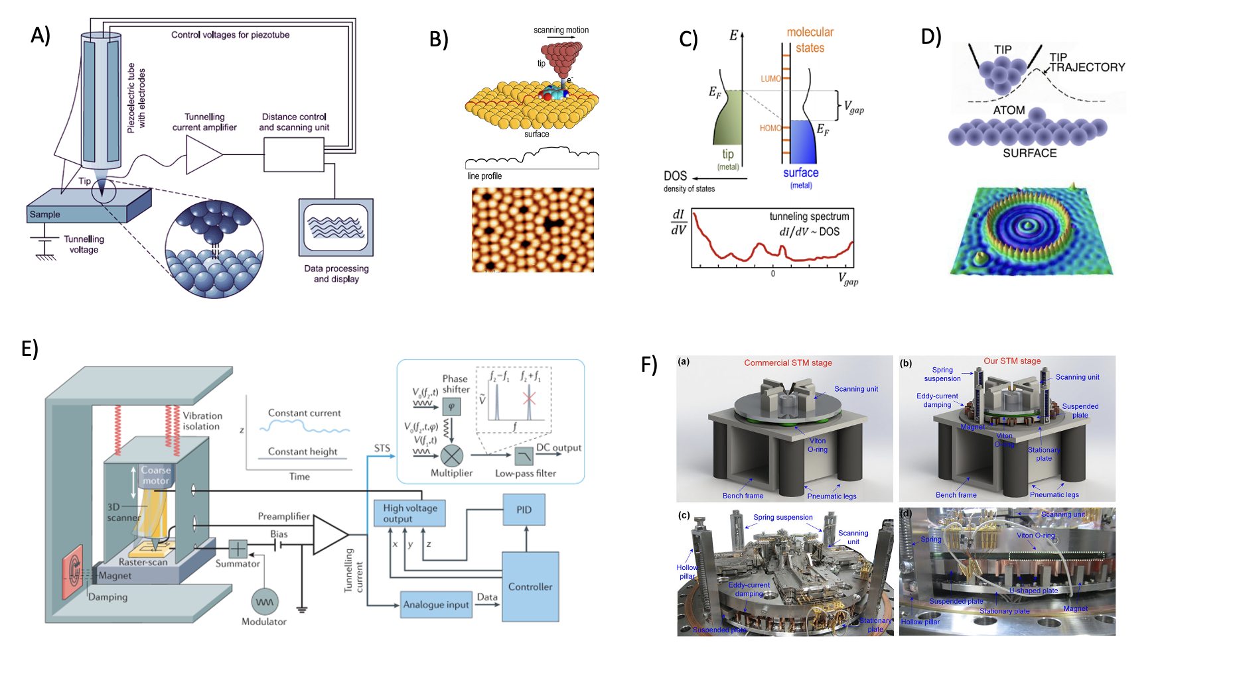

Although the precise control and data acquire system the STM have equipped [Fig1.E)], and the STM typically comes equipped with ultra-high vacuum system and vibration isolation tables, which serve to eliminate external vibrations and surface contamination. Surface cleaning techniques like sputtering and thermal annealing are available used to achieve atomic flat sample. [Fig1.F)]. Because of the variant of the tips, drift, electronic noise and external vibration, different types of artefacts and high-level noise are usually present in the STM images [Fig2.A)]. the damage of the tips such as the tips-sample interaction or crashing can cause irregular variation in tunnelling current, leading to artefacts in the STM images. Drift and electronic noise in the STM system can also contribute to the noise in the image. External vibration can cause the tip to move and result in blurred or distorted images[Fig2.B)].

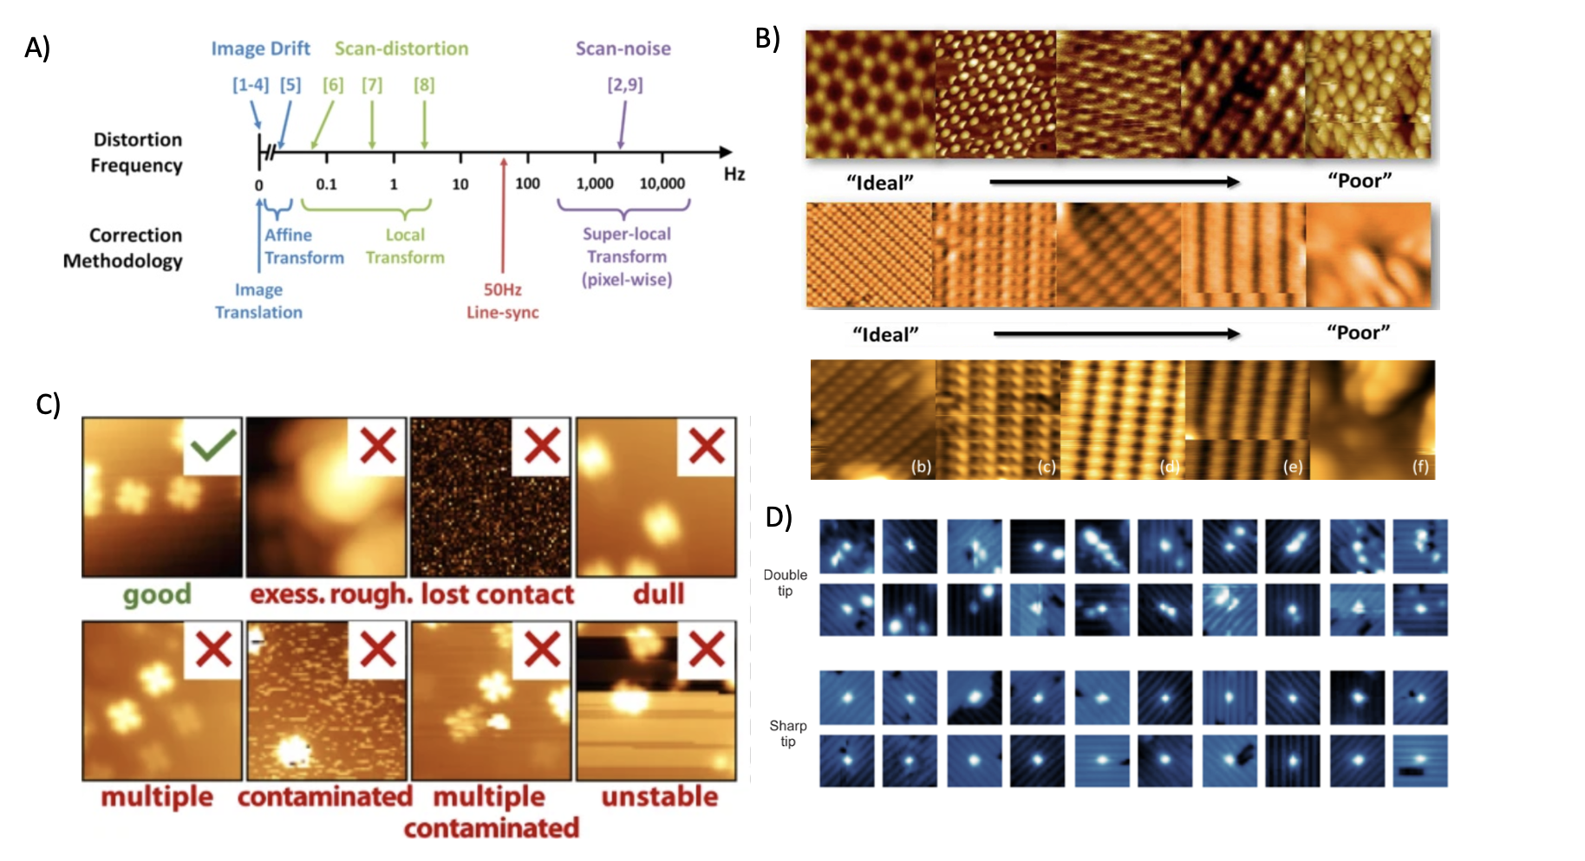

However, obtaining high-resolution images in STM much more than that. The sharpness of the tip, which allows for atomic-scale resolution imaging and manipulation of the sample surface, is hard to optimize and easily gets damaged during the process of data acquirement. The tip-sample distance and the feedback control system are also important factors that contribute to the stability and precision of the STM measurement. The accurate measurement of tunnelling current and the precise maintaining of tip-distance should be guaranteed to achieve high-resolution STM images [Fig2.C)]. In practice, various sets of parament will be tried and adjusted manually based on the operator's experience to keep the STM in the best status, including conditioning the STM tip to maintain sharp enough to get the atomically resolved image and selecting the proper region to avoid the damage of the tip [Fig2.D)].

In terms of data analysis, although tools such as Gwydion, WSXM, and SPIP are available to process the STM images, images with artefacts and noise are always hard to analyze, domain knowledge is highly needed to decide how to process and extract statistics from the data. batch processing, such as subtracting a fitted plane from all images and exporting to a suitable image file in these packages, are available which can greatly improve the speed of processing for sets of similar images and save amounts of time in STM processing, it requires time to manually sort the images, and decide on the processing needed and dealing with the low-quality data is still a challenge. As the advanced of instruments and large volume of data have been generated which is overwhelming and hard to analysis by traditional method, at the same time patch of time are needed to decide how to process them case by case. Therefore, it is important to carefully control the experimental conditions and use appropriate image processing techniques to reduce noise and artifacts in STM images.

The application of machine learning to scanning tunneling microscopy (STM) has emerged as a promising tool to assist in the collection and analysis of STM data. Machine learning is a subfield of artificial intelligence that focuses on developing algorithms and statistical models that enable computers to learn from data and make predictions or decisions making based on that learning. The combine of machine learning with STM in terms of data operation and analysis has the potential to improve the accuracy and efficiency of data collection and interpretation, particularly in cases where the data is noisy or difficult to interpret using traditional analysis methods. For example, A recent work from JQS, which apply machine learning to predict the behavior of atoms and molecules on surfaces, helping researchers to design new materials and devices with specific properties. As these technologies continue to advance, they will likely enable new discoveries and applications in the fields of surface science and nanotechnology. It can help to reduce the time and the cost of experiments, enable the discovery of new materials or phenomena, and provide a deeper understanding of the underlying physics and chemistry of the system being studied. Additionally, the combination of machine learning with advanced instrumentation such as STM can provide a powerful new tool for materials design and discovery. The ability of machine learning algorithms to analyze images consistently, objectively, quickly, and adaptively makes them superior to humans in many images analysis tasks.

The deep learning algorithms can learn complex patterns and relationships in the data and can be used to classify and predict the properties of materials at atomic scale. It can also be used to automate the analysis of STM data, allowing for the rapid identification of features and patterns in large datasets. This can save time and reduce the risk of human error. Materials design: machine learning can be used to design new materials with specific properties, based on insights gained from STM data. This can accelerate the development of new materials for application in electronics, energy, and other fields. In the terms of STM automatic operation, it can enhance the accuracy and speed of real-time feedback control: Machine learning algorithms can be used to provide real-time feedback control of STM experiments, allowing for the optimization of experimental conditions and the collection of high-quality data. Interpretation of results: machine learning algorithms can aid in the interpretation of STM data, providing insights into the underlying physics and chemistry of the materials being studied. This can lead to new discoveries and a deeper understanding of the propertied of materials at the atomic scale.

The application of machine learning (ML) to scanning tunneling microscopy (STM) is a relatively new area of research that has gained significant attention in recent years. The potential of ML in STM lies in its ability to process and analyze large amounts of data generated by STM, allowing for the identification of subtle patterns and features that may not be discernible to the human eye. Manual analysis of microscopy images can be a long and tedious process, which is also prone to human error and bias, Providing reliable and unbiased results. Recent advances in machine learning, particular in deep learning techniques such as convolutional neural networks (CNNs) and recurrent neural networks (RNNs), have enable the development of more sophisticated algorithms for analysing STM data. These algorithms can be trained on large datasets of STM images, allowing them to recognize patterns and extract useful information from the data.

One of the earliest applications of ML in STM was reported in 2009, where a neural network was used to identify and classify adsorbed molecules on a surface based on their STM images. Since then, there have been several studies exploring the use of various ML algorithms for image analysis and feature extraction in STM, such as convolutional neural networks (CNNs), principal component analysis (PCA), and support vector machines (SVMs). Current state of art in ML-assisted STM includes the development of automated and intelligent systems for analyzing STM images, such as identifying atomic structures and defects, predicting properties of materials, and optimizing STM experiments. There is also ongoing research to improve the accuracy and efficiency of ML models for STM, as well as exploring new application of ML in STM, such as the use of generative models for synthesizing novel materials with desired properties.

However, applying machine learning to STM also poses several challenges. For example, the data generated by STM is often noisy and can be affected by experimental artifacts, making it difficult to obtain high-quality training data. Additionally, the interpretation of the results obtained from machine learning algorithms can be complex and may require expert knowledge in materials science and physics, Nevertheless, the potential benefits of applying machine learning to STM make it can excite and rapidly growing area of research.

Feature extraction: STM generates large amounts of complex data, which requires effective feature extraction techniques to reduce the dimensionality and identify important patterns and features.

Training data: machine learning algorithms require a large amount of high-quality training data to learn patterns and make predictions. Obtaining high-quality training data from STM experiments can be challenging due to the presence of noise and experimental artifacts

Choice of algorithm: There are several machine learning algorithms that can be applied to STM data, including neural networks, decision trees, and support vector machines. The choice of algorithm depends on the specific application and the nature of the data being analyzed

Interpretation of results: the interpretation of the results obtained from machine learning algorithms can be complex and may require expert knowledge in materials science and physics. The results must be carefully validated to ensure their accuracy and reliability.

Application to materials design: the goal of applying machine learning to STM is to use the insights gained to design new materials with specific properties. This requires a deep understanding of the underlying physics and chemistry of the systems being studied, as well as the ability to generate and test new hypotheses using STM and other experimental techniques.

The potential research questions are that can machine learning algorithms accurately predict the electronic and structural properties of materials based on STM data? How can machine learning to be used to automate the analysis of large STM datasets, and what insights can be gained from this analysis? Can machine learning algorithms aid in the design of new materials with specific properties, based on insights gained from STM data? How can machine learning be used to optimize experimental conditions in STM experiments, and what impact does this have on the quality of data collected? What new discoveries can be made by applying machine learning algorithms to interpret STM data, and how can these insights be used to develop new materials and technologies? How can machine learning be used to enable real-time feedback control in STM experiments, and what impact does this have on the accuracy and reliability of the data collected? What are the limitations of applying machine learning to STM, and how can these limitation be addressed to enable further progress in the field?

Applying machine learning to scanning tunneling microscopy (STM) has the potential to significantly advance our understanding of the properties of materials at the atomic scale. By leveraging the power of machine learning algorithms to analyze large and complex datasets generated by STM experiments, we can gain new insights into the structural and electronic properties of materials and develop new materials with specific properties for a wide range of application. Some potential significant contributions of applying machine learning to STM include improve accuracy and precision: machine learning algorithms can help to reduce errors and increase the accuracy and precision of STM measurements and analyses.

Rapid and efficient data analysis: machine learning algorithms can quickly and efficiently analyze large and complex STM datasets, enabling researchers to identify patterns and trends that would be difficult or impossible to discern manually.

Development of new materials: by using machine learning to analyze STM data, researchers can gain insights into the properties of materials at atomic scale and develop new materials with specific properties for various applications.

Real-time feedback control: machine learning algorithms can be used to enable real-time feedback control in STM experiments, allowing researchers to optimize experimental conditions and improve the quality and reliability of the data collected,

in many decision-making processes, there is a vast amount of data that needs to be processed in order to make an informed decision. Machine learning algorithms are designed to process and analyze large amounts of data quickly and accurately. They can identify patterns in the data that are not immediately obvious to humans and use this information to make predictions about future outcomes. In many decision-making processes, there is a vast amount of data that needs to be processes in order to make an informed decision. Machine learning algorithms are designed to process and analyze large amounts of data quickly and accurately. They can identify patterns in the data that are not immediately obvious to humans and use this information to make predictions about future outcomes. Machine learning algorithms can also adapt to changing conditions and learn from experience. This means that they can continuously improve their predictions over time as they are exposed to more data. Overall, machine learning is suitable for decision making process because it can help to identify patterns in data, make predictions based on this information, and adapt to changing conditions over time. This can lead to more accurate and effective decision making in a wide range of application.

Decision-making in systems that are not fully understood is too complex to be characterized analytically or following a well-established set of rules. Machine learning promises to revolutionize decision making and data analysis. It can help scientists obtain high-quality data by optimizing the parameters of STM controlling and extract meaningful information from experimental data, even from highly noisy data, which could change the situation of just keeping the high-quality image for analysis, discarding the low-quality data. In this review, we review the recent progress of implementing machine leaching techniques to the STM controlling and data analysis in the first place. Then, we discuss the machine learning algorithms and data resources used to solve these problems. Our goal is to summarize and highlight resources and platforms that can enable us to use these methods in STM controlling, data processing, and analysis.e

1. **The autonomous operation of STM**
   1. Optimization of control parameters

The challenge of the autonomous operation of STM is to achieve the precise state of the probe and tune the associated control parameters automatically by the algorithm for a particular image type. Traditionally, during the optimization of tip and imaging parameters, the perceived quality of the image is entirely based on operator experience rather than arising from a well-defined metric. As a pioneer's work, Richard A. J. Woolley et al. develop a machine learning protocol for the control and optimization of the structure of a scanning probe used for atomic resolution imaging, they apply a cellular genetic algorithm(cGA) to optimize the control parameters, including the tunnel current setpoint, the sample bias voltage, integral gain, and proportional gain. Fig.1 shows the graphite surface used as a test for the atomic resolution capabilities of an STM. As we can see in Fig.1 A, the quality of the image is highly improved after the optimization of the evolution of cGA, the trend for an increase in fitness is highlighted by a dashed line, and the similarity between target and acquired image for the cGA phase is assessed by calculating the robust mutual information (RMI) shared between the two images. The system has the ability to self-tune and evolve to different STM images of the same surface Fig.1 B show the genetic algorithm-optimized 4×2 nm 2 atomic resolution images, The trigonal Fig.1 B(a) and honeycomb Fig.1B(b) symmetry for the graphite surface has tuned itself to the predefined targets shown in Fig.1 B(c) and Fig.1 B(d) with this system, respectively. Line profiles Fig.1B(e) and Fig.1 B(f) show the characteristic repeat pattern of carbon atoms for each type of image. Fig.1 C is the identical imaging parameters of different images of the same scanned area during the cGA phase, Fig.1 C(a) and Fig.1 C(b) show the images acquired with the same area, In Fig.1 C(c) The three individuals in each image (delimited by solid black lines) have close to identical imaging parameters. The step of optimization is as follows: Initially, a large area (200× 200 nm 2) scan is taken, and the quality of the image is assessed by surface roughness, voltage pulse(s) are applied, and the scan is repeated until the image of the surface becomes atomically flat. After a flat (200× 200 nm 2) image is achieved, the system incrementally decreases the scan window size. At each step, the image quality is assessed using a combination of metrics. For scan sizes, ≥50 nm, the presence of step edges and surface defects are used to ascertain surface quality. If the surface is measured as atomically flat, the scan size is reduced further, for the 20× 20 nm 2 image, Fourier analysis reveals structure consistent with the graphite lattice the scan size is reduced to the final magnification level of 20× 20 nm 2. Here again, the Fourier components are ascertained and, as a quantifiable measure of quality, the scan is cross correlated with a target image. In this work, the optimization algorithm is based on a cellular genetic algorithm (cGA), which belongs to a subclass of GAs in which the individual (potential solution) only inherits characteristics from its closest neighbors during the breeding cycle. The evolutionary protocol here not only coerces an STM to produce high-quality atomic resolution images of a particular type but, because any scanning probe image involves a convolution of tip and surface structure, opens the possibility of intelligently engineering the atomic architecture of the apex of the probe. The roughness of the surface to assess the STM status with large image space then optimize the control states to smaller ones then used the surface defects and presence of step edges as a criterion and fully used the lattice constant to assess. the criteria used in this paper may somehow reflect the states of tips and STM states, but the reality is more complicated than that. another more generalized classifier needs to be trained that can classify different type of STM image and assess the quality of it.

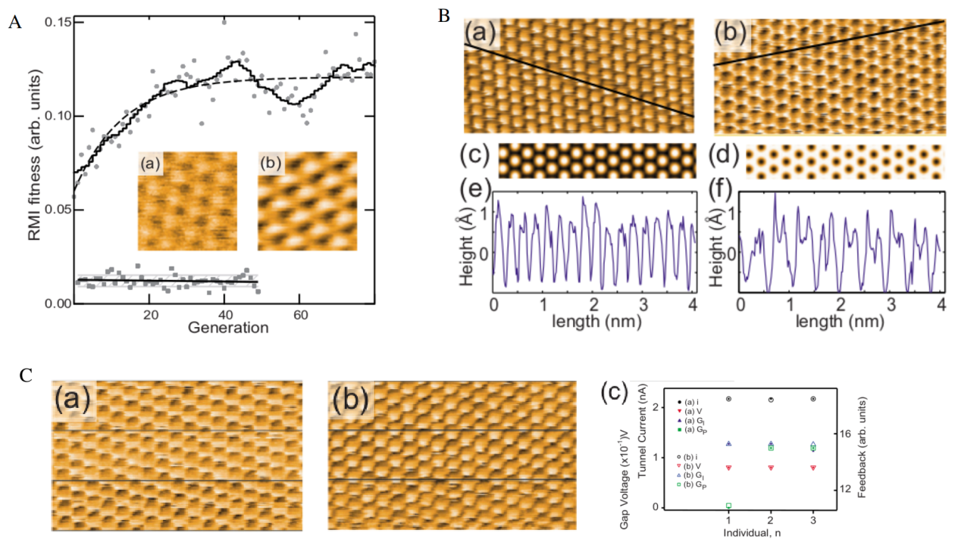

**Figure 1. The images of the graphite (HOPG) surface used to test the performance of the cellular genetic algorithm(cGA) generations.** (A) The evolution of the system toward a higher quality image as a function of the number of cellular genetic algorithm(cGA) generations, the robust mutual information (RMI) is used to assess the similarity between target and acquired image for the cGA phase. (B) Genetic algorithm-optimized 4×2 nm 2 atomic resolution images, the trigonal (a) and honeycomb (b) symmetry for the graphite surface has tuned itself to the predefined targets shown in (c) and (d) with this system, respectively. Line profiles (e) and (f) show the characteristic repeat pattern of carbon atoms for each type of image. (C) the identical imaging parameters of different images of the same scanned area during the cGA phase, (a) and (b) show the images acquired withe the same area, (c) The three individuals in each image (delimited by solid black lines) have close to identical imaging parameters.

* 1. Conditioning of STM tips

Scanning tunneling microscopy consists of scanning an atomically sharp probe in close proximity above a surface while measuring a physical quantity (quantum tunneling current in scanning tunneling microscopy) as a function of probe position. Since the signal is controlled by the overlap of the electronic wave functions of tip and surface, the atomic-scale morphology of the probe and the state of the sample imaging regions are two main factors in STM data acquirement. Different operations require different types of tips, such as tips are sharp enough to obtain atomically resolved image are not able to get published standard spectrum, or good enough for atom manipulation, and tip with magnetic atoms on the apex can achieve spin resolved. Although sharp tips are readily created ex-situ, imperfections in the tip apex including the presence of “double” or multiple tips mean that image artifacts often appear spontaneously during experimental sessions. To maintain resolution, apex flaws must be repeatedly corrected in situ through a repeated combination of controlled voltage pulsing and/or tip crashing. Common methods include applying short voltage pulses between the tip, and sample or controllably indenting the tip into the sample. These processes typically must be repeated many times before the tip’s quality is restored and tip status is assessed highly dependent on humans' experience. So it is a time-consuming task, and it is difficult to assess the state of tips, the tips state maybe change during images acquirement, there are a lot of factors that can have an effect on the tips states and there is no formula type to repair tips, and it is difficult to reproduce in reality, thus, effective way to assess the tip states and optimize the step of tip repair automatically is highly needed. Sumit Tewari et al. demonstrated a method for shaping a metallic tip apex in STM. By placing an adatom on a smooth Au surface the structure of the tip apex can be imaged, and they find that the shape of the STM tip evolves surprisingly smoothly and reproducibly towards an atomically sharp and symmetric structure of the second layer from the tip apex atom, starting from any random and poorly defined tip shapes. Fig.2 A shows the evolution of the tip apex, leading towards a symmetric and reproducible structure. Fig.2 A(a) shows a non-circular image of an adatom due to the random tip structure at the start. The inset of (a) shows a constant-current image of two separate adatoms prepared on the surface to confirm that the asymmetric structure is due to the tip. Fig.2 A(b–f). Between each of the images, 20 mechanical annealing cycles are applied. The schematic representation of the tip preparation process proposed and the consecutive conductance traces of contact breaking in this article are shown in Fig.2 (B and C).

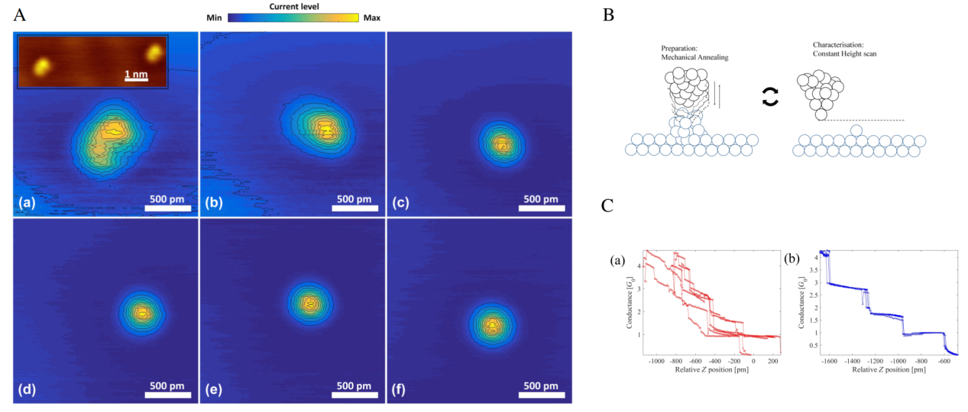

**Figure 2. The assessment and in-situ repair of STM tips.** (A) The six panels show constant-height images of a single adatom. Panel (a) shows a non-circular image of an adatom due to the random tip structure at the start. The inset of (a) shows a constant-current image of two separate adatoms prepared on the surface to confirm that the asymmetric structure is due to the tip. The evolution of tip apex is shown in the next panels, leading towards a symmetric and reproducible structure (b–f). Between each of the images we applied 20 mechanical annealing cycles. The contours shown are linearly spaced in current. For ease of comparison the current levels in the images have been normalized to the maximum current level, which for the panels (a–f) are 66, 31, 26, 26 , 25 and 22 nA, respectively. (B) Schematic representation of the tip preparation process proposed in this article, where mechanical annealing cycles were followed by constant height scans made over a single adatom deposited on the surface.(C) Six consecutive conductance traces of contact breaking showing (a) an initially non-repetitive structure that is converted after mechanical annealing into (b) repetitive conductance traces. The conductance is expressed in units of the quantum of conductance, G 0 = 2e 2 /h.

With the development of machine learning, ML methods derive decision strategies from training data, which can routinely outperform humans in the field of object recognition, image segmentation, and classification. Mohammad Rashidi et al. for the first time apply the convolutional neural network (CNN) to evaluate the status of the STM tip. In this work, they trained a model to detect and recondition the quality of the probe of a scanning tunneling microscope and can achieve high accuracy, these techniques were employed on the technologically relevant hydrogen-terminated silicon surface, training the network to recognize abnormalities in the appearance of surface dangling bonds. It can evaluate the quality of an SPM probe and perform in-situ conditioning to restore the quality of degraded tips. The first step of this task is to prepare the training data, they labeled approximately 3500 STM images including sharp tips and double tips(labeled with “0” or “1” ). Randomly selected labeled data set used for training are shown in Fig. 3 B. Then those labeled images were fed into a CNN to train a classifier that can classify good images (sharp tips) and bad images (double tips). Fig. 3 A. shows the tip quality analysis with the convolutional neural network. The CNN consisting of two convolution layers followed by a pooling layer, a densely connected layer, and an output layer(Fig. 3 A(c)) is used to assess the status of tips. The result of the output layer is “0” for sharp tips or “1” for double tips. As an example, the output of each CNN layer is shown for the dangling bond image in Fig. 3 A(b). Fig. 3 A(d) The outputs of the CNN for each automatically extracted dangling bond image in Fig. 3 A(a). Autonomous tip sharpening used along with atom-scale patterning shows in Fig. 3 C(a), a spot (red cross) chosen by the user to perform tip conditioning, Once the tip became double, the tip conditioning routine is employed to resharpen it.

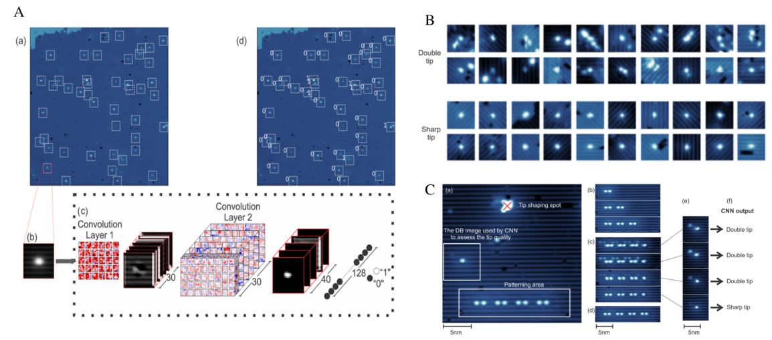

**Figure 3. The process of in situ tip conditioning for double tips.** (A) Tip quality analysis with convolutional neural network. (a) STM image (100 × 100 nm 2) of hydrogen-terminated Si(100) recorded at −1.80 V and 50 pA. Bright features are surface dangling bonds. The dangling bonds are automatically extracted from the image (white-dashed squares) and sequentially fed into the CNN. (b) Close up of the dangling bond indicated by the red square in (a). (c) A depiction of the CNN used in this study. It consists of two convolution layers followed by a pooling layer, a densely connected layer, and an output layer. The result of the output layer is “0” for sharp tips or “1” for double tips. As an example, the output of each CNN layer is shown for the dangling bond image in (b). (d) The outputs of the CNN for each automatically extracted dangling bond image in (a). (B) The labeled data set used for training. 5.6

× 5.6 nm 2 dangling bond images are extracted from the STM images recorded at −1.8 V and 50 pA. (C) Autonomous tip sharpening used along with atom-scale patterning. (a) An overview (25 × 25 nm 2 ) STM image showing a patterned binary atomic wire, an isolated DB used for tip quality assessment, and a spot (red cross) chosen by the user to perform tip conditioning. (b) Sequence of patterning steps without noticeable tip quality change in between. (c) The tip became double after the creation of the last atom on the right, and the user employed the tip conditioning routine to resharpen it. After three steps of automatic tip conditioning, the tip became sharp and the user carried on the pattering (d). (e) STM image of the isolated DB at middle left of (a) after each tip conditioning. The CNN used these images to assess the quality of the tip. (f) Output of the CNN for the images in (e). The tunneling conditions were −1.8 V and 50 pA for all images.

Apart from classifying sharp tips and double tips in H: Si(100) surface, a much wider set of classifications is possible, including “atoms” (for the sharpest tips), “dimers,” “asymmetries,” and “rows.” O. Gordon et al. trained a convolutional neural network protocol for multi-class tasks that enables automated recognition of a variety of desirable and undesirable scanning tunneling tip states on both metal and nonmetal surfaces. Figure 4 A shows the example images of these classifications. Since “Double tips,” “tip changes,” “step edges,” “impurities,” and image corruption “defects” are artifacts that could apply to any surface, two other commonly surfaces Cu(111) and Au(111) was studied for generalization. In this work, the images of H: Si(100) were manually classified into the four tip states listed above (i.e., atoms, dimers, asymmetries, and rows) and two other categories, tip changes, and generic defects. Similarly, Au(111) and Cu(111) images were classified into five categories of undesirable defects and one desirable state of sharp resolution. Although they achieve significantly greater all-around performance than other supervised learning techniques and have a strong ability to differentiate good and bad tip apices, the performance between different surfaces indicates that CNN architectures respond differently to different surfaces. Each trained ensemble is only applicable to a single surface, performance should be improved with the addition of more training data and potentially combined with time-dependent data to allow for real-time classification and tip enhancement during scanning. Figure 4 B demonstrates a potential method to allow neural networks to predict the state of an SPM tip using incomplete scans. Rather than training/predicting with complete scans, the network (green border) can instead be allowed to predict a small group of individual line scans. The work uses the multi-task network to classifier different types of the image which can be more productivity in reality, and the way of detecting the state in the process of image acquiring can highly enhance the efficiency of data acquirement.

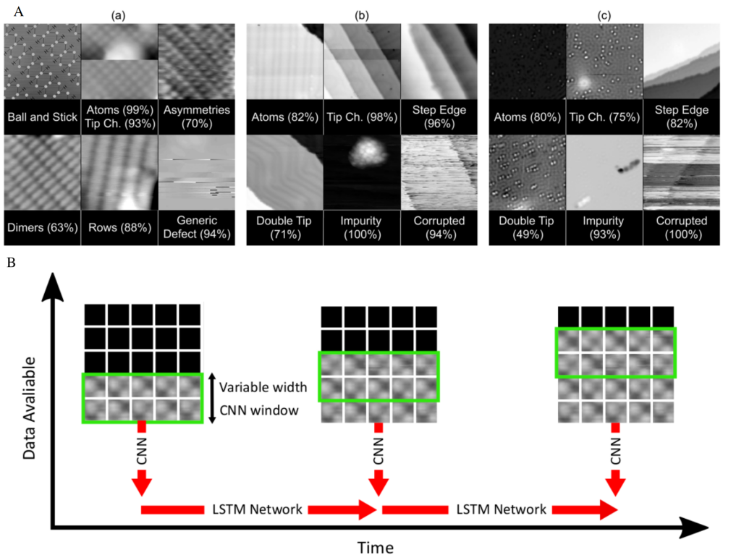

**Figure 4. The process of in situ tip conditioning for multi-condition.** (A) Selection of images demonstrating key tip states for STM imaging of (a) H:Si(100), (b) Au(111), and (c) Cu(111), and the confidence thresholds of convolutional neural networks used to classify them. In many examples, features can appear to strongly blend between images, such as with asymmetries and dimerlike modulation in rows in (a). Because creating unambiguous training data was impractical, we therefore combined these classes. (B) Figure to demonstrate a potential method to allow neural networks to predict the state of an SPM tip using incomplete scans. Rather than training/predicting with complete scans, the network (green border) can instead be allowed to predict a small group of individual linescans. This window of CNNs can then be rolled to make additional predictions as successive line scans become available over time. The outputs of these CNNs can then be fed into a second temporal neural network, to make a final prediction.

To condition tips that suitable for conduct dI/dV spectra, Shenkai Wang et al. employed a straightforward height-based segmentation algorithm to analyze STM topographic images to identify tip conditioning positions and used 1789 archived dI/dV spectra to train machine learning models that can ascertain the condition of the tip by evaluating the quality of the spectroscopic data. Fig.5 A shows the diagram of applying machine learning models to identify the Au(111) Shockley surface state in dI/dV point spectra and perform tip conditioning on clean or sparsely covered gold surfaces with minimal user intervention. This task consists of locating tip conditioning positions and evaluating tip conditions from dI/dV spectra. Machine learning models were trained on a library of archived dI/dV spectra on Au and AdaBoost was selected as the default for the automated tip conditioning software, as it is robust, adaptable, and faster than other models, which is shown in Receiver operating characteristic (ROC) curves for machine learning models (Fig.5 B(a)). Fig.5 B(b) shows the feature importance of random forest model, which is consistent with the experience of humans.

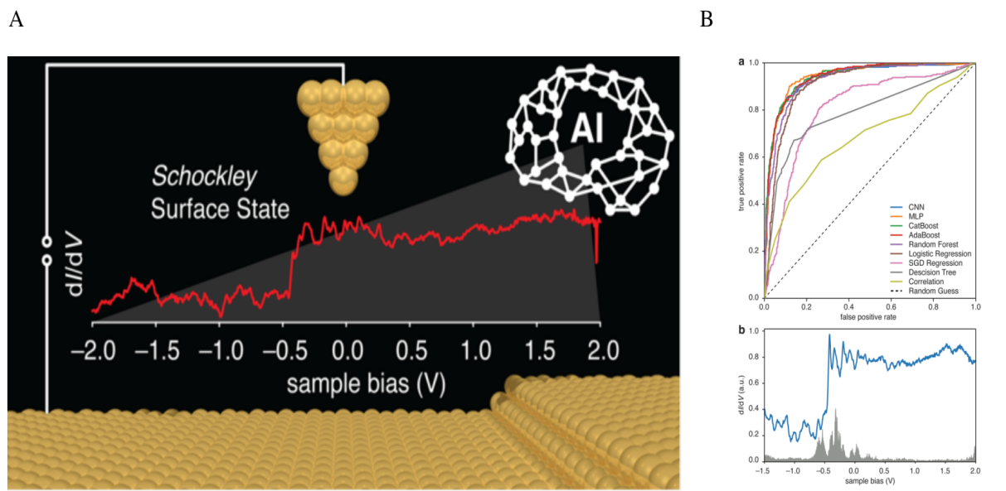

**Figure 5. The process of in situ tip conditioning for STS spectrum.** (A) The diagram of applying machine learning models to identify the Au(111) Shockley surface state in dI/dV point spectra and perform tip conditioning on clean or sparsely covered gold surfaces with minimal user intervention. (B) Performance of machine learning models on diﬀerentiating STS curves with gold surface states. (a) Receiver operating characteristic (ROC) curves for machine learning models. (b) Contribution of each data point on the classiﬁcation of STS curves using a random forest model (feature importance).

* 1. Autonomous scanning tunneling microscopy

The major challenges for autonomous STM operation are to deal with the unsupervised control parameters optimization, automate repair of STM tips, constant external noise suppression, and intelligent segment or pattern recognition of STM images. The first task is to empower the STM the ability to assess the tips states themselves and take the action to optimize until the best states it can achieve. The CNN is commonly used in images classification, which can be used to classify STM images from good condition to bad condition and reinforce learning network can be trained to repair the tip, which can highly improve the ability of autonomous controlling. In reinforcing learning an agent is used to do action according to current states, and a reward function and evaluate machine are there to assess the action is the right or bad decision when optimizing the parameter continually until it can meet the criteria mentioned above. In the article “**Artificial-intelligence-driven scanning probe microscopy**”

. Recently, A. Krull et al. developed an artiﬁcial intelligence-driven scanning probe microscopy(DeepSPM). They claim that DeepSPM can acquire and classify data continuously in multi-day scanning tunneling microscopy experiments, and keep the probe quality for varying experimental conditions. Figure.1A shows the workflow of the autonomous scanning probe microscopy, including a convolutional neural network to assess the quality of acquired images, and a deep reinforcement learning agent to reliably condition the state of the probe. Figure.1B shows the process of images assessment and probe repair, first of all, with the pro-processed image as an input, an algorithm assesses whether the sample region is overly rough, the probe–sample contact is lost, or the probe has crashed into the sample, then images are fed into the neural network to classify the states of the probe. If the classiﬁer CNN concludes that the probe is bad, DeepSPM uses the deep reinforcement learning agent to attempt to repair the probe by selecting and applying a probe-conditioning action. The capability of optimizing the control parameters of STM, and automatic repairing the probe indeed improve the effect of STM operating, However, it needs a lot of data to train the machine learning model and a lot of time are needed to label STM images( such as the high-quality data and poor-quality data), so that machine learning models can learn from those data and optimize the STM states for high-quality data. Thus, the common method to assess the tip states is needed to make this method more wildly used and generalized. In addition, the model trained in one database is not necessarily suitable for another STM instrument, and the machine learning module it has learned for particular materials cannot be directly used with other STM, but, the network and pre-trained module can be used to train own network with the data acquired in your own STM, the way of scanning in this work can reduce the noisy come from drift and distort, it is also can optimize the scanning path to skip the bad region in the STM image. So, we should pay more attention to generalize this module and include more labeled data to learn and a more generalized module to develop and make the machine learning models have the ability to segment, locate the image and assess the quality of image data automatically.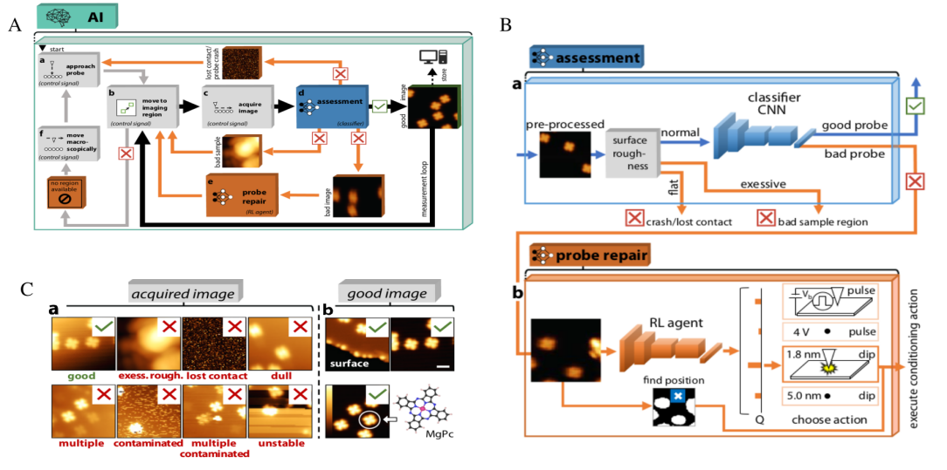

**Figure 6. Workﬂow of autonomous scanning probe microscopy (SPM). (**A) The entire workﬂow consist of image data acquisition, assessment, and issue resolution by DeepSPM. (B)The framework of Intelligent assessment(a) and probe repair(b). (C) Examples of variable imaging conditions.

1. **The processing and analysis of microscope images**
   1. Atomic location and defects detection

Image segmentation is the critical method in the analysis of STM data, Image segmentation is a pixel-based classification and merge to the whole according to its label, it is easy to start with the thresholding algorithms that can separate the image to different part based its intensity or location. However, different thresholding value are required to determined manually, the error or base can be introduced in this process, and it could be case by case and can not accommodate to the large volume data generated by modern instrument.

For the classification and location for atom, individual image pixels are analyzed by the spectral information that they contain and values of pixels within the locality are ignored. This is the traditional approach to classification since the pixel is the fundamental (spatial) unit of a microscope image, and consequently it comes naturally and is often easy to implement. In this sense each pixel would represent a training example for a classification algorithm, and this training example would be in the form of an n-dimensional vector, where n was the number of spectral bands in the image data. Accordingly, the trained classification algorithm would output a class prediction for each individual pixel in an image. The application of this pixel-based classification to experimental data allows us to identify positions of individual atoms in the lattices as well as location of different types of defects. Fig.7 is the example of finding atomic position from raw experimental images.

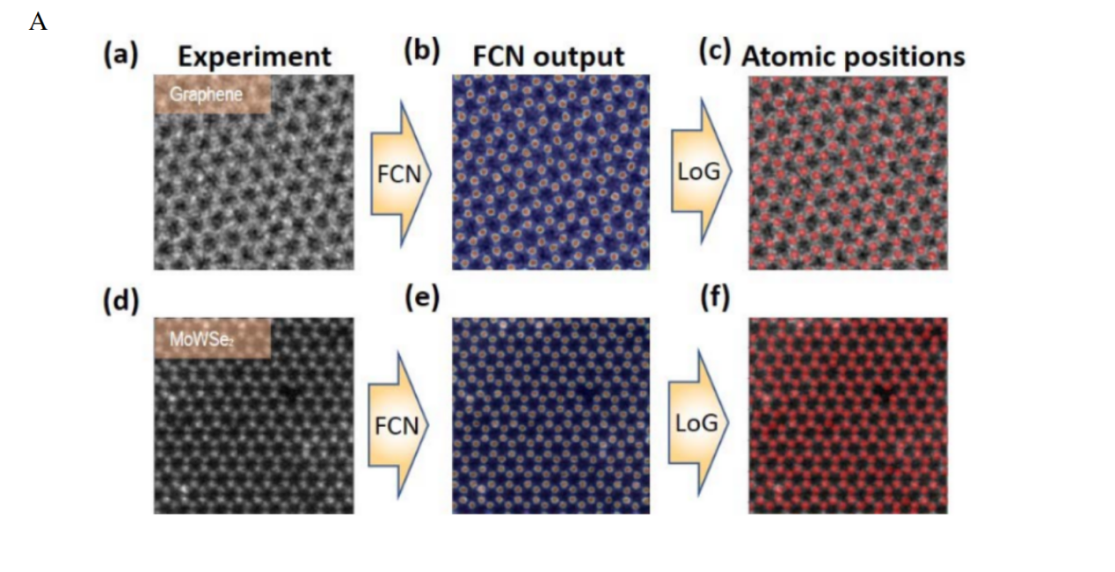

**Figure 7. Finding atomic position from raw experimental images. (**A) (a-f) show how the atomic position are obtained, ( a-c) is graphene and (d-f) is Mo1-xWxSe2

* 1. Detection and location for molecules

Pixel-based classification is not suitable for this task, classification should be done on a localized group of pixels, considering the spatial properties of each pixel as they relate to each other. In this sense a training example for a classification algorithm would consist of a group of pixels, and the trained classification algorithm would accordingly output a class prediction for pixels on a group basis. For a crude example, an image might be partitioned into n segments of equal size, and each segment would then be given a class, Figure 8. shows a example of detecting bounding boxes and location of DNA molecules. In this task, YOLOv3 model was used to scan and identify the location and the bounding boxes of DNA molecule.

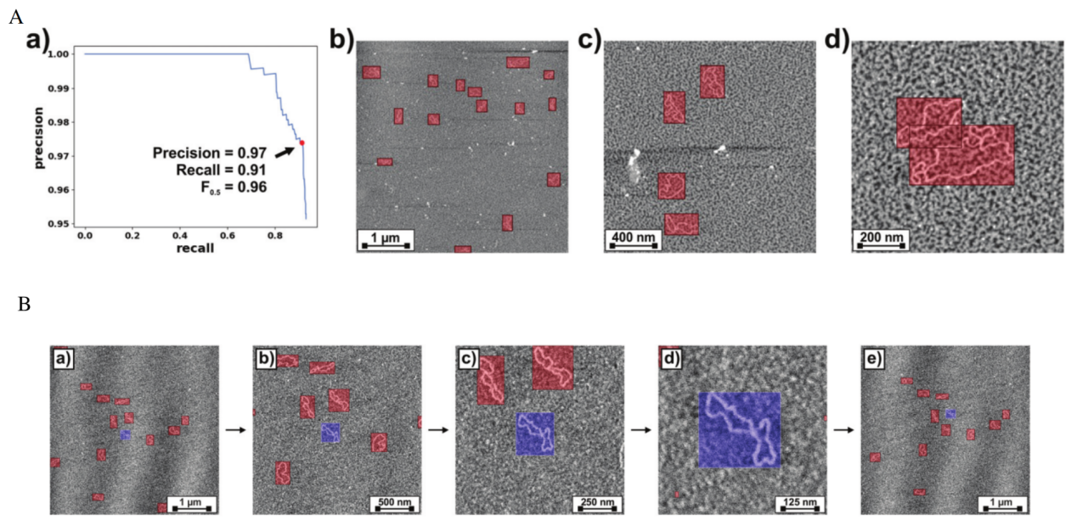

**Figure 8. Bounding boxes detection and location for DNA molecules. (**A) (a) Precision–recall curve calculated by applying our YOLOv3 model to the test dataset of DNA AFM images. The point for maximum of 0.5 value is highlighted. (b–d) Representative AFM images from the test dataset where the DNA bounding boxes predicted by our YOLOv3 model are over-imposed. (B)(a–e) Consecutively acquired AFM images representative of the workﬂow of the autonomous imaging algorithm. Bounding boxes for the detected DNA molecules are over-imposed; the one corresponding to the molecule on which the new scan will zoom on is drawn with blue transparency whereas the rest are drawn with red transparency.

* 1. Local structure detection

The segmentation is necessary process for this task, the goal of the segmentation process is to change the characteristics of the image into more meaningful ones, thus facilitating interpretation and classification. Usually, we want to locate objects and boundaries in the STM images. Simplest example is removing background from foreground. Because these image segments better represent objects than do the original pixels, each step of the classification process, from defining training sites to classifying from these segments, is simplified. It is also possible to achieve better accuracy. The common salt-and-pepper effect that results from a pixel-based classification is reduced and a more cartographic-grade map is the result. Unlike traditional pixel-based classification methods, segment-based classification is an approach that classifies a microscope image based on image segments.

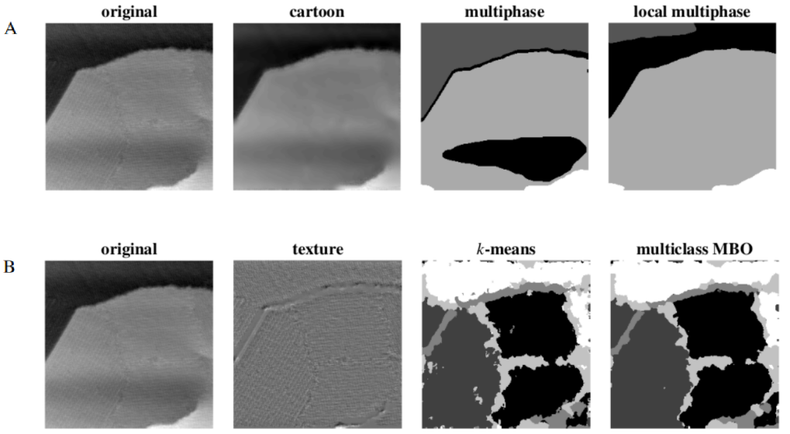**Figure 9. Scanning tunneling microscope images of the annealed CN/Au{111} with six separate ribbon domains with three different relative rotations of the ribbon direction.** (A, B) STM images of annealed CN/Au {111} are clustered by different algorithms

The segmentation module generates an image of segments where pixels identified within a segment share a homogeneous spectral similarity. Across space and over all input bands, a moving window assesses this similarity and segments are defined according to a user-specified similarity threshold. The smaller the threshold, the more homogeneous the segments. A larger threshold will cause a more heterogeneous and generalized segmentation result. Figure 9. shows scanning tunneling microscope image of the annealed CN/Au {111}. Different type of images is shown for different algorithms.

The next step in the classification process is to derive training sites and signature classes from the image segments. In addition to the current signature development tools, the module creates training sites and signature classes based on the image segments. With an intuitive graphical interface, you can interactively select segments of interest as sample sites for classes. Once a segment is selected, all pixels in that segment are used for signature development. These images can then be used as input into one of the classifiers.

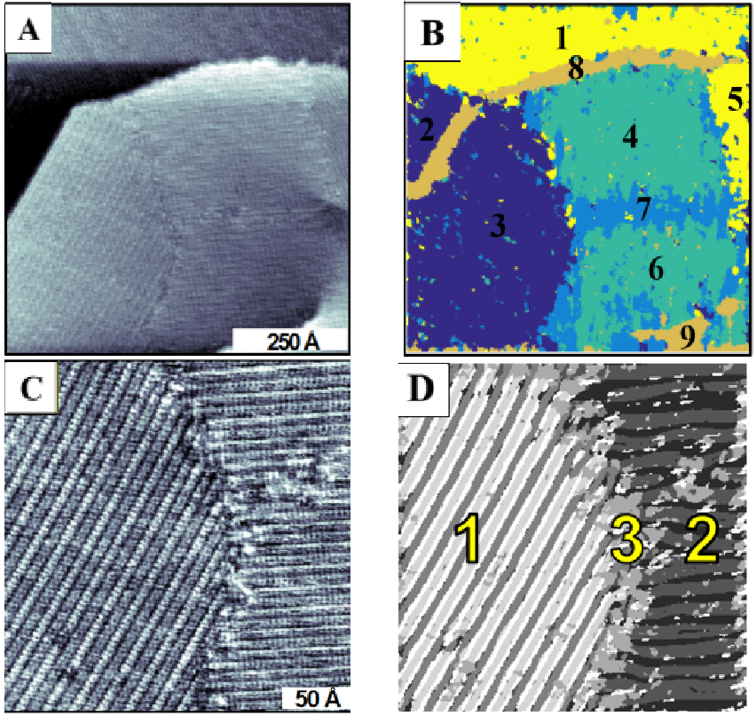

**Figure 10. Scanning tunneling microscope image of the annealed CN/Au {111} with six separate ribbon domains with three different relative rotations of the ribbon direction.** (A, C) a STM image of annealed CN/Au {111}. (B) Regions1–6 represent ribbon regions with each color indicating a ribbon region of a different

rotational orientation. Region 7 is a ribbon domain boundary, and regions 8, 9 are step edges. Ribbon orientations are relatively offset by rotations of multiples of 60° following the hexagonal close-packed symmetry of the underlying gold lattice. (D) Segmentation analysis results showing the domain boundary (3) and

the rotational domains (1 and 2).

The last step in segment-based classification is to classify the image segments. This is done with the assistance of a reference image. A reference image is an already classified image. This image can be created using the segment-based signatures or some other approach. The important point here is that this reference image is used to assign the majority class within each segment. Figure 10. shows scanning tunneling microscope image of the annealed CN/Au {111} different regions can be classified, as shown in Figure 10 B, Regions1–6 represent ribbon regions with each color indicating a ribbon region of a different rotational orientation. Region 7 is a ribbon domain boundary, and regions 8, 9 are step edges. Ribbon orientations are relatively offset by rotations of multiples of 60° following the hexagonal close-packed symmetry of the underlying gold lattice. and Figure 10 D shows the domain boundary (3) and the rotational domains (1 and 2). A majority rule algorithm is applied within each segment to determine its class assignment. Since the base unit in a segment-based classification is an image segment, the accuracy may improve upon the pixel-based classification and produce a cartographic-grade classification result as well. It also provides the user with a variety of classification choices for the creation of the reference image. The option also exists for combining the many pixel-based classifiers or the simulated orders with this approach to create a hybrid classification procedure not found elsewhere. There have been experiments on segmenting images with the help of classification algorithms. zhang et al. use ANN to fit the experimental data with the theoretical model to detect a new quantum state is an example of using machine learning techniques to analyze STM data. Figure 11. (A) shows the training ANN.

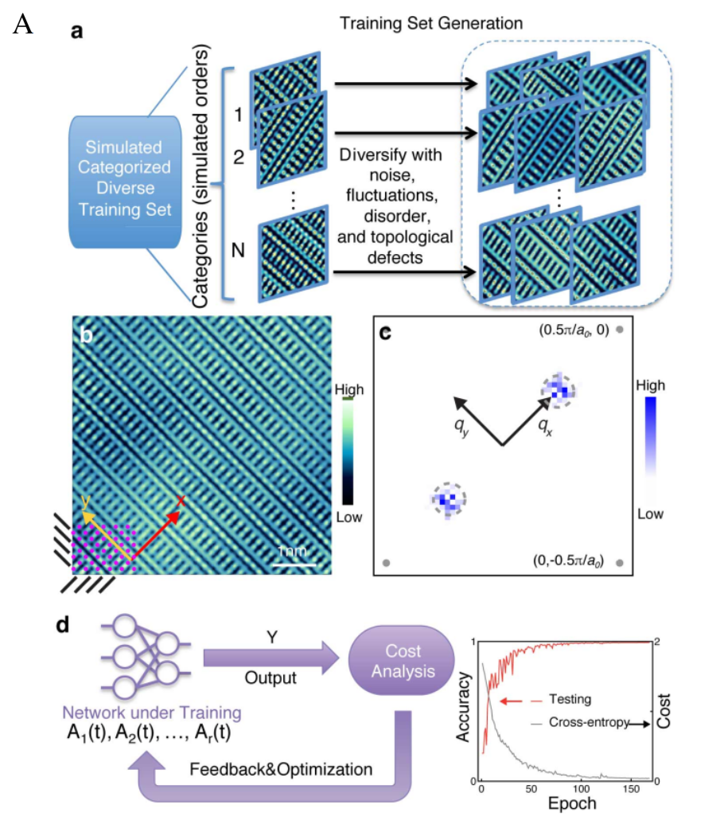

**Figure 11. (A) Training ANN to identify broken-symmetry states in SISTM data**. a, The ANN array is trained to recognize a DW in electronic structure images representing different EQM states. A synthesized training-image set for the ANNs is obtained by appropriately diversifying pristine images of 4 distinct electronic ordered states.

In the work named *Machine learning in electronic-quantum-matter imaging experiments*, the electronic quantum matter is studied by the method of ANN(artificial neural networks), the highlight of this work is to apply this approach to experimental data, and recognize different type hidden order in electronic quantum matter images

1. **Extract insight from STM image**

Another aspect of work focus on extracting information from experimental data, in one recent work, they apply PCA to analyze the DOS map of BSCCO and extract the main factor of the feature and cluster for different components, as shown in Fig 12. the method used here is called unsupervised learning. The unsupervised learning is one type of machine learning, which can learn from unlabeled data and exact useful information from data, including clustering and dimension reduction. Complex data will become easy for analysis after dimension reduction and clustering. zhang et al. combines experiment data with theory model to analyze it data, they use ANN to fit the experimental data with the theoretical model to detect a new quantum state is an example of using machine learning techniques to analyze STM data. Another work used DFT to generate molecules model and try to predict the structure of STM data is a good try, because structure-property based machine learning is productivity and can achieve high accuracy, so it has the potential to combine both and can get a more exciting result in the future. 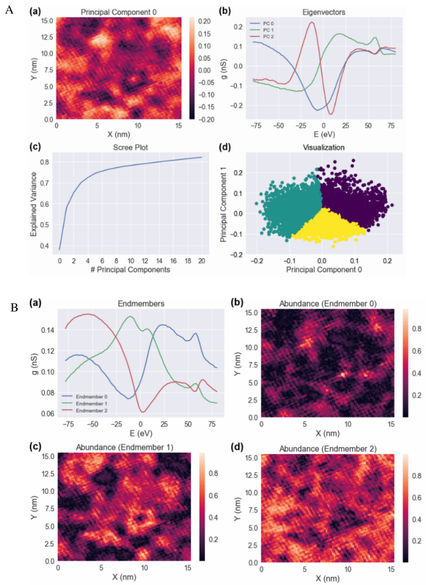

**Figure 12. The analysis of DOS**. A PCA visualizations of a BSCCO DOS map with 81 energy points. (a) The first principal component scores, plotted spatially, contains most of the information of the DOS map. (b) First three PC eigenvectors w. (c) Scree plot, showing the cumulative explained variance vs. number of principal components. (d) 2D visualization of the dataset, plotted by the first two principal component scores. The colors show how one might go about using the PCs to segregate clusters in the data (though this data is not well segregated by PCA, an analysis of the clusters pictured here is presented in Fig. 2-10 as a demonstration of usage of the technique). B Linear Unmixing of a BSCCO DOS map into three endmembers. Same dataset as Figures 2-4and 2-5. (a) Endmember spectra; each pixel is interpreted as a linear superposition of these spectra. (b-d) Abundance maps 𝑎 𝑖for each of the endmembers in (a). These could potentially be interpreted different electronic states in the system.

STM data can provide the surface structure, FFT transform is a power tool to detect the periodicity of structure in the traditional way and for the machine learning, CNN can reflect the frequency both in large scale and locally. combining with dimension reduction and principal components analysis, the full connected neural network is a powerful tool to analyze the structure and can get the main factor or the main component of the structure. One example is to apply clustering to analyze the DOS map of BSCCO, which have a complicated electronic structure and cannot be easily detected by a human being, they exact the first three components that have a contribution to the density of the state and used the clustering to locate region to reflect this kind of contribution, which is helpful for the analysis of data. the algorithm used here is unsupervised learning, which means you do not need a lot of data to train it and just extract some useful information from STM data. By combining theory model and the experiment, scientists can fit the STM data to find out which model has more probability to consistent to your STM image. zhang et al. construct the different model with different structure and the using machine learning algorithm to fit the experimental data and find a new quantum electronic matter, Another similar work applied DFT to construct the model mode, and by matching the simulation model with the experimental data, it can find the atomic model directly, there are a lot of machine learning usages, which apply structure to predict the property to accelerate the process of material discovery and a lot of reviews you can find easily. Because STM can provide the structure information locally so it is convenient to combine the STM data to predict some useful properties, At the same time the local density of electronic states obtained from STM can be highly connected to the DFT calculation and the data of ARPPES, which can make full use of the data both from DFT calculation and experimental to get more meaningful insights. STM can provide a lot of information, from the topology and electric structure to vibration information localized, due to the noise and the complied of structure and electronic states it is not an easy task to analyze the STM data, I will introduce the recent progress of how machine learning can be used to help us process image and extract useful insight from STM data. The first problem is how to deal with the image with noise and distort, someone, introduce a method to process the distorted and developed a different way to deal with the common noise caused during the acquiring of data, another one report another way after the correction using the method mentioned about and then repeat scanning for many times than average it does can reduce the noise. machine-learning can also do such thing, someone tries to extract useful information from noisy data directly and it highly increases the efficiency and also other machine learning algorithm trying to de-noise the STM from the data acquired which also have the good performance, so machine learning does have the ability to process the noisy data. When we get the image data, the first step is to process the data order to further analysis, then define the structure of the STM image, for the DOS image we can combine the experimental data with the DFT calculation. So, it can be consistent with each other and find out the contribution of each orbit all this process can be replaced by machine learning with little effort. We can just use FNN to replace FT and use clustering and PCA to define the main components of each eigenvalue and then analyze it, construct different structures that can properly exist in the STM image, and combine DFT to find out which one is more suitable for this kind of structure. the final goal is to combine anomalous control and image analysis and the STM instrument can acquire data atomically and analyze data intelligently at least it can help us process the image in the first place so that we can get more information from the raw data, the challenge here is how to generalize our model so that it can be used by more people.

1. **Outlook and perspective**

Machine learning can be used in STM controlling and image processing and some productivity has been achieved in the past, make full use of these techniques can enhance our efficiency and can also help us to find more useful insight, manipulation of the atom can be used to construct the artificial structure which plays an import role in quantum computation and nano-structure device. At the same time, the high throughput data acquirement can help to build the database of materials, which plays an important role in materials design and discovery. Although a lot of encouraging result has been achieved, there is also some more detailed work that needs to be done. The cooperation of interdisciplinary should be highly encouraged, take the autonomous operation of STM as an example, a wide range of techniques are needed to such as how to interact with STM interface, the expert plays an important role in feature selection and the sequence of action design. The skills of machine learning and image processing should meet the true need of the scientist and experimental data should be processed to find the best explainable mode combined with the DFT calculation and theory mode, there are bundles of work need to be done and it is also a very productive subject because the large of information the STM can provide, and the machine learning is superior to human beings in the complicated control system and parameters optimized. At the same time, the complex information in the STM data analysis is not that easy for human beings so machine learning techniques should be used to accelerate the process. In this review, I have introduced machine learning and point out what can we benefit from these techniques and reviewed the recent progress in these areas.